LAB 5 – Stored procedures and Triggers

Create database and insert data to store information of employees as following

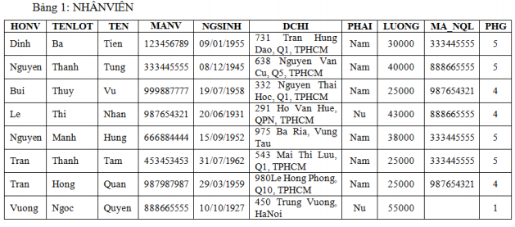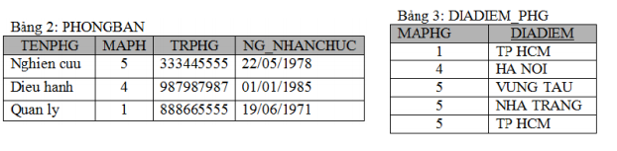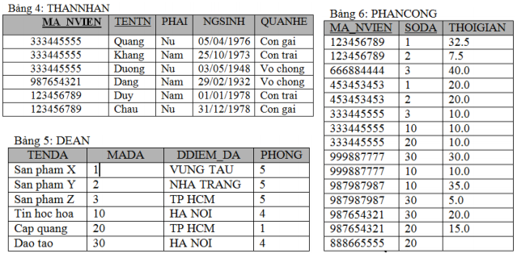

1. Write store procedures to do bellow tasks: (SPs were named SP_[number])
2. List all information of employees (code, name, entered date, supervisor’s id, supervisor’s name) that were employed from s to f. S and f are date value that were been input parameters.
3. List all employees (code, name, salary) whose salary more than the average salary of the department that they work in.
4. List N employees that have the highest salary. N is the input parameter.
5. Increase 10% for salary of all employees in the city A. A is the input parameter.
6. Delete all no personnel departments.
7. Write triggers to ensure:
8. The average salary of each department must be fewer than 50000.
9. The salary of the head of each department must be greater than or equal to salary of all employees in this department.
10. The different between average salary of employees in HCM and HN must fewer than 10000.
11. There is not group that have more than five employees that are in the same family.
12. The different between number of male and female employees must fewer than 10%.